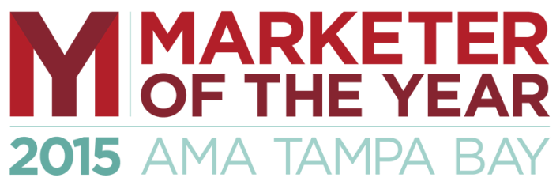
Sponsorship Opportunities
Signature Sponsor: (1 Exclusive) $2,500
- Opportunity to Present the Educator of the Year Award
- Co-branded through-out entire promotion
- Company description presented by the MOY emcee
- Full page, 4 color Program Ad
- Preferred Table Seating for 8 with Company Branded Signage
- Your Company logo and backlink on new AMATB website for one year
- Your Company logo on rotating events slideshow shown at the MOY event
- One sponsor featurette in AMATB e-newsletter
- One social media thank-you on each of AMATB’s social channels where available
- Member pricing on MOY tickets
- Opportunity to distribute company literature to all attendees
- First right of refusal on next year’s Signature Sponsorship
MOY Awards Sponsor: $2,500 total value:
- Cash payment of $1,500, plus a $1,000 sponsor package:
- Podium mention and recognition at the MOY event
- Your Company logo and backlink on new AMATB website for one year
- Your Company logo on rotating events slideshow shown at the MOY event
- One sponsor featurette in AMATB e-newsletter
- One social media thank-you on each of AMATBC’s social channels where available
- Member pricing on MOY tickets
- Opportunity to distribute company literature to all attendees
- First right of refusal on next year’s Award Sponsorship
In-Kind Sponsorship Opportunities
- MOY Program Design
- MOY Entertainment Sponsor
- MOY AV Sponsor
- MOY Video Sponsor
Advertising Opportunities
- MOY Program Advertiser: Full page, 4 color: $500 Also includes Two free admissions
- MOY Program Advertiser: Half page, 4 color: $250 Also includes One free admission
Table Sponsors
MOY Table Sponsor: $800 Bring your whole team! Also includes:
- Preferred Table Seating for 8 with Company Branded Signage
- Podium Mention / Recognition at the event
      - Your Company logo on rotating events slideshow shown at the event

For more information on Sponsorship opportunities, please contact:
Brenda McGowan bmcgowan@AnchorComputer.com

